

PRESS RELEASE Prague, 29 April 2019

PASSERINVEST GROUP is the third most admired company in the Czech Republic

The investment and development company Passerinvest Group won third place in the top 100 most admired companies in the Czech Republic in 2019 announced by the CZECH TOP 100 Association. Passerinvest Group also defended first place in the industry category of “Activities in the areas of real estate, enterprise services”. There are also firms among the top ten most admired companies that have long been headquartered in BB Centrum, a project of Passerinvest Group: ŠKODA AUTO a.s., ČEZ, a.s. and UniCredit Bank Czech Republic, a.s.

“Last year we rose in the rankings from 8th to 6th place. We consider his year’s third place to be a huge success and we receive it with humility and thankfulness towards the Lord. We see this award as a result of the good work of the whole company, my colleagues, who not only take care of our customers in BB Centrum and Ostrava, but also about projects that concern the long-term and sustainable development in the places we operate,” stated Radim Passer, the founder and CEO of Passerinvest Group, with regard to the received award.

The CZECH TOP 100 Association organised the rankings for the eleventh time this year and the awards ceremony took place on Thursday, April 4th in the French restaurant of Prague’s Municipal House. The CZECH TOP 100 rankings are made on the basis of the evaluations of managers of important companies, economic and financial analysts, representatives of union organisations and professional associations.
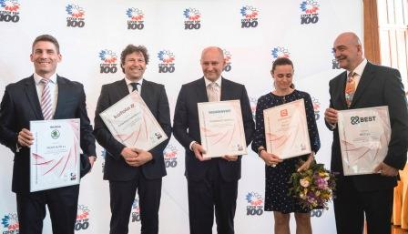
Representatives of the top five companies in the 100 most admired companies of the Czech Republic. From the left: the representatives of ŠKODA AUTO a.s. and Kofola ČeskoSlovensko a.s., Radim Passer, the founder and CEO of PASSERINVEST GROUP, a.s., and representatives of ČEZ, a.s. and BEST, a.s.

You can get more information and photographs in print quality from:
Kristýna Samková, Head of PR and Marketing Department
PASSERINVEST GROUP, a.s.
Tel.: (+420) 221 582 111
E-mail: Kristyna.Samkova@Passerinvest.cz
www.passerinvest.cz, www.bbcentrum.cz

Marcela Štefcová
Crest Communications a.s.
Mobil: (+420) 731 613 669
E-mail: marcela.stefcova@crestcom.cz

About the company

PASSERINVEST GROUP, a. s., is a purely Czech development and investment company, whose name is primarily connected with the realisation of the multifunctional BB Centrum complex in Prague 4 – Michle. The company, established by Radim Passer in 1991, built a very good reputation both on a local and international level with this, the most successful and extensive project of its kind in Central Europe. This is not only to the credit of the quality of the realised projects and the high level of the provided services, but also due to the sense of fair play, a customer approach and especially responsibility to the society and the environment. PASSERINVEST GROUP also has other interesting investment and development projects in its portfolio, as well as projects that serve the general public and citizens of Prague.

